Home Inventory

By Alma Knudson and Bill Ford

The home inventory web application keeps track of a person’s valuables and has three purposes. Keeps track of valuables, shows when a warranty expires, tracks maintenance done on an item, and creates reports for insurance company along with a picture of each item.

There will be five or more web pages. These are “home”, “registration”, “inventory”, “report”, and “single” item page. The home page and registration pages are the only ones a visitor can access without being fully registered.

The home page is a welcome page and introduces the company and how it can benefit the end user. It also contains two text boxes and a login button that allow the user to type in there username and password if they are already a registered user. There is a registration button that allows the user to register to use the website.

The registration page has six text boxes along with labels that allow the user to type in their demographic information. They can choose username and password. The password is entered twice to make sure they enter the correct password. The username must be unique and be at least five characters. The password needs to be 6 characters in length and must include a digit and a special character. The name, address and phone number will be validated as is appropriate. Once a user is registered, they can access all the other pages and there will be links to the other pages.

The inventory page show a listing of the current inventory. It will also have an add button to add more items to the inventory. There will be two more buttons delete and save that allow the user to make modifications as necessary. The inventory list will be a table of following fields:

1. Quantity
2. Description
3. Vendor
4. Category
5. Value
6. Data of Purchase
7. Warranty Expiration Date
8. Serial Number
9. Policy Number
10. Picture of the item

The header row of the inventory table listing will be clickable to allow for sorting the inventory by each of the fields listed above except for the picture. A report of a single item or a group of items can be generated by clicking on an inventory item or a policy number for a group of items

The Report page will allow the user to create a report of an item lost and is covered by an insurance policy. Whether an item is covered by insurance, needs warranty work, or maintenance it will be the same item report. This report will contain all the fields of the line item and a picture of the item along with the insurance policy information and the owner of the policy. This report will be able to be exported and saved as a PDF. This PDF can then be emailed, printed or faxed using the capabilities of the computer.

The Insurance page will allow the user to enter in different policies and then select that in the inventory under Policy Number which will tie the inventory item to the policy. Multiple policies are beyond the scope of this project.

All of this information including pictures will be stored in a database and contain the following information.

Database

1. Users
   1. Login
   2. Password
   3. Name
   4. Address
   5. Phone
2. Insurance Table
   1. ID
   2. Agent
   3. Phone
   4. Policy #
   5. Policy Date
   6. Max Coverage
   7. Category
      1. Home
      2. Car
      3. Life
3. Inventory Table
   1. ID
   2. Login
   3. Category
      1. Jewelry
      2. Electronics
      3. Appliance
      4. Furniture
      5. Yard
      6. Vehicle
   4. Description
   5. Value
   6. Date of Purchase
   7. Warranty Date
   8. Next Maintenance Date
   9. Vendor Phone
   10. Vendor
   11. Picture of Item ( Blob stored in Database or as a filename of picture)
   12. Insurance

Below are some screen shots.

Index Page:



Inventory Page:

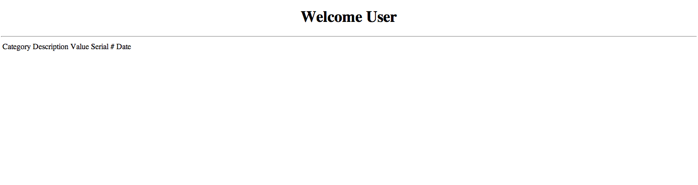

We will add functionality to add, remove, and edit inventory items that are displayed on this page. We will also add a link that will automatically send an e-mail to his/her insurance company.

Register Page: